Decoding Hypersonic Aircraft: The Science and Engineering Behind Flight at Mach 5+

Research Paper
Author: SAI SATYAM JENA
Class: VIII
School: DAV PUBLIC SCHOOL
Date: August 2026

Abstract
Hypersonic flight refers to flight at extremely high speeds, generally beginning at Mach 5. At these speeds, aircraft experience unusual aerodynamic, thermal, and propulsion challenges. This paper investigates the fundamental science and engineering involved in hypersonic flight, including Mach number, shock waves, aerodynamic heating, propulsion, materials, and flight control.

1. Introduction

Hypersonic flight refers to the motion of aircraft, missiles, or spacecraft through the atmosphere below the Karman line at speeds greater than March 5 or five times the speed of sound, or over 3,800 mph/6,100km/hr. Hypersonic flight represents one of the most challenging areas of aerospace engineering. At these speed their could be a lot of issues like air friction creating extreme heat that turn the surrounding air into glowing plasma and that can damage or melt the parts of aircraft. An aircraft traveling at several times the speed of sound interacts with the atmosphere in ways that differ significantly from ordinary aircraft.

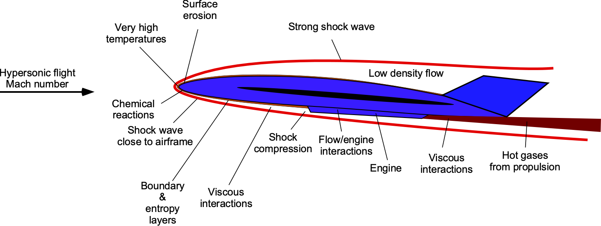

The purpose of this research is to investigate how hypersonic aircraft operate and why maintaining flight at such high speeds presents major engineering challenges.

Research Question:

How do hypersonic aircraft achieve and sustain speeds above Mach 5, and what scientific and engineering challenges do they face?

Understanding Mach Number

The Mach number is a unitless number that shows the ratio of the speed of an object to the local speed of sound of the sound in that same medium or in simple terms to measure “How fast something is moving compared to the speed of sound”.
For example, if an aircraft travels at five times the local speed of sound, its speed is approximately Mach 5.
The speed of sound is not constant everywhere. It changes with atmospheric conditions particularly temperature. Therefore, Mach number is more useful for describing high-speed flight than simply stating a speed in km/h.
Example citation:
Hypersonic flight is generally associated with speeds of Mach 5 or greater (NASA, 2024).

Speed Categories:
Subsonic (Less than Mach 1): Slower than sound (like normal passenger planes).
Sonic (Mach 1): Exactly the speed of sound.
Supersonic (Mach 1 to Mach 5): Faster than sound (like fighter jets).
Hypersonic (Greater than Mach 5): Extremely fast, five times faster than sound or more (like space rockets).

The Mach Number Formula
$$M=\frac{v}{a}$$
Where:
- M= Mach number
- V= velocity of the aircraft
- A= local speed of sound

Simple Example:
If an aircraft is traveling at 1,700 m/s and the local speed of sound is 340 m/s. Find its Mach number.
A= $M=\frac{1700}{340}=5$
Therefore, the aircraft is traveling at Mach 5.

Why Mach Number Matters
Why engineers use Mach number instead of only km/h?
A= Especially because the speed of sound changes with atmospheric conditions.
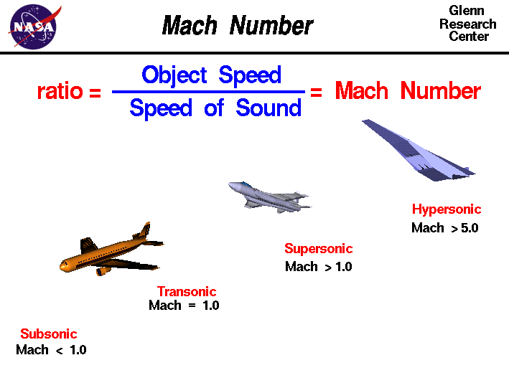

Aerodynamics at Hypersonic Speeds

At hypersonic speed, the interaction between the aircraft and the surrounding air becomes extremely important and Hypersonic aerodynamics is a special branch of the study of aeronautics. The chief characteristic of hypersonic aerodynamics is that the temperature of the flow around the aircraft is so great that the chemistry of the gas must be considered. At these extreme velocities, kinetic energy turns into massive heat. Air molecules vibrate, break apart, turns into plasma, creating intense shock waves, thick boundary layers, and serve surface heating and changes in pressure and temperature affect aerodynamic forces.

Key Features of Hypersonic Flow
Thin Shock Layers: Shock waves hug the body tightly because the gas compressed behind the wave is very dense.
High Aerodynamic Heating: Heat transfer to the skin scales up with the cube of the velocity (v³), causing extreme temperatures that melt standard metals.
Real-Gas Effects: Air stops acting like a simple ideal gas. High heat splits oxygen (O₂) and nitrogen (N₂) molecules into reactive single atoms.
Viscous Interactions: Thick boundary layers interact with shock waves, changing the effective shape of the aircraft and altering pressure.

The shape of hypersonic aircraft therefore has to be designed with both aerodynamic performance and thermal effects in mind.

Design Choices for Hypersonic Craft
Blunt Noses: Rounded shapes create a detached shock wave that pushes hot gas away from the main body, protecting the vehicle.
Waveriders: Specialized wedge-like lower surfaces use the craft's own shock wave to trap high-pressure air and generate extra lift.
Special Materials: Titanium, carbon-carbon composites, and advanced thermal protection tiles are required to survive the heat.

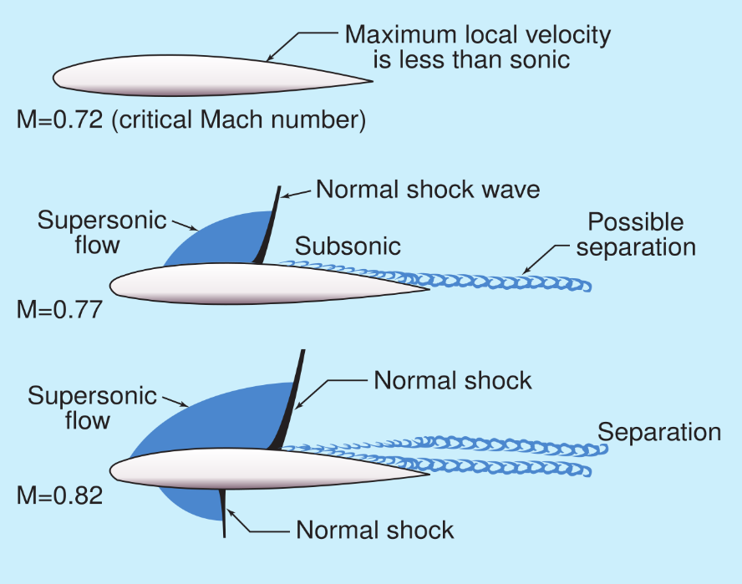

Shock Waves and Compression

At hypersonic speeds (Mach 5 and above), air behaves less like a smooth fluid and more like a highly compressible wall. Because the aircraft travels faster than the speed of sound, the air ahead receives no warning of its approach. It cannot move out of the way smoothly, causing a violent, instantaneous pressure buildup.

1. The Physics of Hypersonic Shock Waves
Tightly Swept Oblique Shocks: At lower supersonic speeds (Mach 2), shock waves spread out wide. At hypersonic speeds, the shock wave bends back sharply, hugging the body of the aircraft closely.
Shock-Layer Interaction: The gap between the shock wave and the physical surface of the aircraft narrows into a thin layer. This trapped pocket becomes a chaotic environment of high-pressure, high-velocity air.
Bow Shocks and Stagnation Points: Sharp edges create attached shock waves. However, perfectly sharp edges melt at Mach 5+. Hypersonic vehicles must use slightly blunt noses and wing edges. This creates a detached bow shock just ahead of the vehicle, trapping a small pocket of intensely compressed air at the "stagnation point" where the air is forced to a dead stop.

2. Intense Air Compression and Its Consequences
Extreme Aerodynamic Heating: Compression causes a massive temperature spike. Air passing through the shock layer can instantly heat up to 1,500°C to 5,000°C+.
Chemical Dissociation: The compressed air gets so hot that oxygen and nitrogen molecules physically tear apart into individual atoms. This turns the air around the aircraft into an electrically charged plasma field, which can block radio signals and alter the aerodynamic properties of the vehicle.
Density Changes: The air density behind the shock wave increases dramatically, creating a thin but incredibly heavy layer of air rushing over the vehicle's skin.

3. How Aircraft Engineering Exploits This Physics
Compression Lift (Waveriders): Vehicles like the historic Boeing X-51 or modern glide vehicles are sculpted specifically to trap the high-pressure air generated by their own shock wave underneath their flat bellies. The aircraft literally "rides" on top of its shock wave, generating massive lift with very little added drag.
Scramjet Intake Compression: Hypersonic air-breathing engines (scramjets) do not use mechanical fans to compress air like a typical jet airliner. Instead, they use the precise shape of the vehicle's nose and engine intake to create a sequence of internal shock waves. These shock waves compress the incoming air to the perfect pressure and speed required for fuel combustion.
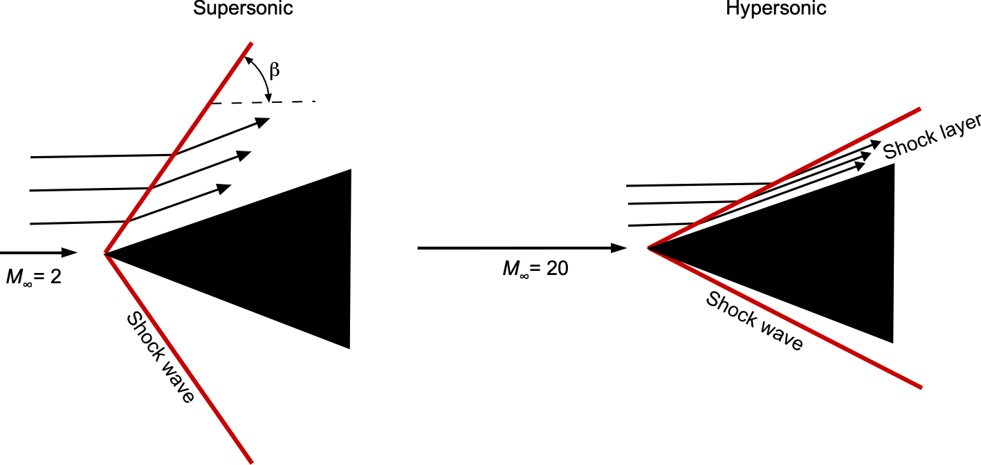
Shock-Boundary Layer Interactions (SWBLI): As the shock wave interacts with the boundary layer (the slow-moving friction layer of air touching the aircraft's skin), it can cause the airflow to violently detach from the vehicle. Engineers use active cooling and complex geometry to prevent this, as a detached boundary layer causes severe structural vibrations and unpredictable melting points.

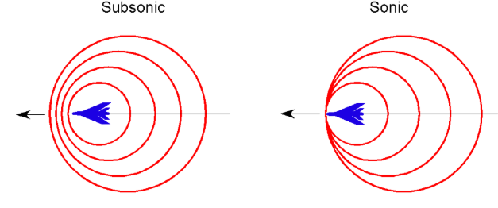

Hypersonic Propulsion and Scramjets

One of the major challenges of hypersonic flight is producing useful thrust at extremely high speeds. Scramjets engines are one technology investigated for hypersonic propulsion. To understand all things first we need to know about Hypersonic Propulsion, Scramjets, and different core engines types use in planes.

What is Hypersonic Propulsion?
Hypersonic propulsion drives flight at speeds greater than Mach 5 (five times the sound barrier, or over 3,800 mph). It relies primarily on advanced air-breathing systems like scramjets (supersonic combustion ramjets) that compress incoming air using high forward speed rather than mechanical moving parts.
Core Engine Types
Scramjet Engines- Allow supersonic airflow through the engine core where fuel is injected and ignited; ideal for sustained atmospheric cruise. It keeps incoming air at supersonic speeds (above Mach 1) throughout the entire combustion process. It operates efficiently from Mach 5 up to Mach 15+. It features a highly contoured, open geometric design to maintain supersonic flow without creating massive shockwave drag. It only has one technical challenge that: Lighting and maintaining a stable flame in a supersonic airflow (often compared to lighting a match in a hurricane).
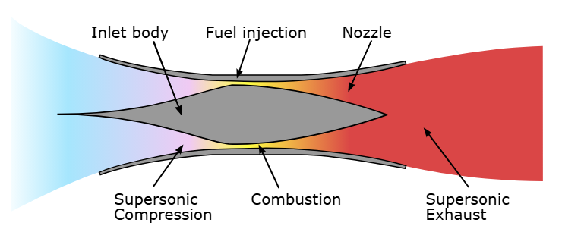

Scramjet Engine

Ramjet Engines- A ramjet engine is a simple, air-breathing jet engine with no moving parts like turbines or compressors. It uses its own fast forward motion to ram and compress incoming air, mix the fuel, and burns it to create powerful supersonic thrust. It decelerates incoming air to subsonic speeds (below Mach 1) inside the combustion chamber. It operates efficiently between Mach 3 and Mach 5. It uses a narrowing inlet to forcefully slow down and compress incoming air. It also has one technical challenge that is: Managing high pressure and thermal choking as speeds approach Mach 5.

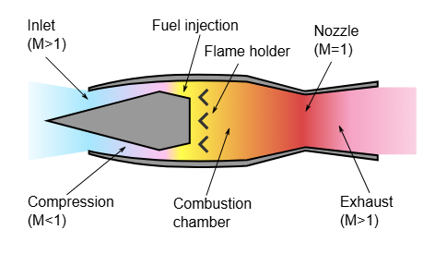

Performance Summary
Feature | Ramjet | Scramjet
Internal Airflow | Subsonic (< Mach 1) | Supersonic (> Mach 1)
Ideal Vehicle Speed | Mach 3 – 5 | Mach 5 – 15+
Ignition Threshold | Around Mach 1 – 2 | Minimum Mach 4 – 5
Inlet Complexity | Moderate | Extremely High

How a Scramjet Works
Air breathing: It takes oxygen directly from the air instead of carrying heavy oxygen tanks like a rocket.
Forward push compression: The fast forward movement of the vehicle squeezes and packs the incoming air tight.
Supersonic burn: Unlike regular jet engines or standard ramjets, it does not slow the air down to a crawl before adding fuel.
Fast ignition: Fuel mixes and burns instantly inside the screaming fast air stream.

How a Ramjet Works
Air Intake: The fast forward movement forces air into the engine inlet at high speeds.
Compression: The incoming air slows down through the shape of the inlet, which raises its pressure and temperature without needing a mechanical compressor.
Combustion: Fuel mixes with the high-pressure air and burns in the combustion chamber.
Exhaust Nozzle: Hot gases rush out of the back nozzle at high speeds, pushing the vehicle forward.

Aerodynamic Heating

At high-speed flight through the atmosphere produces significant heating. The nose and leading edges of a hypersonic vehicle can experience particularly severe thermal conditions.
This creates a major materials and thermal-protection challenge for engineers.
To understand more about heating effect of aerodynamics. First, we need to under that “what is aerodynamics” and basic of aerodynamics.

What is aerodynamics?
Aerodynamics is the science that studies how air moves around the objects and the forces that act on things moving through the air or the study of forces and the resulting motion of objects through air.

The Four Forces-
Lift: The upward push that helps a plane or bird go up.
Weight: The downward pull of gravity.
Thrust: The forward push from an engine or power source.
Drag: The backward push or resistance caused by air slowing things down.

Pressure and Velocity Relationships-
Bernoulli's Principle: When air speed goes up, static pressure goes down.
Dynamic Pressure: Represented as half the air density times velocity squared (1/2 ρ V²).
Venturi Effect: As a tube or space narrows, air velocity increases and pressure drops.

Core Conservation Laws-
Mass: Air entering a continuous stream must equal air leaving it.
Momentum: Total momentum in a closed air system remains constant.
Energy: Total energy in a steady, ideal fluid flow does not change.

Heating Effects of Aerodynamics
Aerodynamics heating is the process where an object’s kinetic energy converts into thermal energy as it moves fast through air. This happens because air compresses heavily at the front nose and rubs against the outer skin. It becomes a big problem during supersonic and hypersonic flight.

Causes of Heating
Air Compression: Shock waves form at the front and compress the gas tightly, which raises its temperature very fast.
Skin Friction: Air rubs along the outer surface inside a thin layer called the boundary layer, turning motion into heat.
Cubic Speed Factor: Heat transfer goes up with the cube of the flight speed (v³), meaning small speed increases make much more heat.

Effects on Vehicles
Material Weakness: High skin temperatures lower the structural strength of metals like aluminium.
Flow Changes: Hot surfaces change how air flows, which can cause the boundary layer to pull away or separate early.
Chemical Reactions: At extreme hypersonic speeds, air molecules break apart into reactive single atoms or turn into glowing plasma.

Ways to Control Heat
Blunt Shapes: Rounded nose cones spread out the shock wave and keep peak heat lower.
Ablative Shields: Outer layers melt or chip away slowly to carry the thermal energy away.
Heat Sinks and Cooling: Special interior designs or active fluid loops absorb and move the thermal load.

Heating of Hypersonic Aircrafts
At hypersonic speeds (Mach 5 and above), extreme air compression and intense viscous friction generate severe aerodynamic heating that scales proportionally with the
cube of velocity. Surface temperatures can exceed 1,600°C, triggering gas dissociation, plasma formation, and complex fluid-thermal-structural instabilities.

Materials and Thermal Protection

Hypersonic aircraft traveling above Mach 5 face intense air friction, causing surface temperatures to exceed 2,000°C to 3,000°C. Thermal Protection Systems (TPS) use specialized heat-resistant materials and active or passive cooling designs to prevent structural failure.

Key Materials Used-
Ceramic Matrix and Carbon Composites
Carbon-Carbon (C/C) Composites: Exceptionally lightweight with high thermal conductivity and strength at extreme heat, though prone to oxidation above certain thresholds.
Ultra-High Temperature Ceramics (UHTCs): Materials like zirconium diboride (ZrB₂) and hafnium diboride (HfB₂) resist melting past 3,000°C.
Ceramic Matrix Composites (CMCs): Silicon carbide reinforced with silicon carbide (SiC/SiC) offers high stiffness and thermal shock resistance.

Ablative Materials: Sacrificial materials like phenolic-impregnated carbon ablator (PICA) erode away in a controlled manner to bleed off extreme heat for single-use or high-flux areas.

Refractory and Metal Alloys-
C-103 Niobium Alloy: A mix of niobium, titanium, and hafnium used in rocket nozzles, heat shields, and liquid-metal pipelines due to its massive melting point.
Nickel Superalloys: Heavy-duty nickel and chromium blends used inside high-heat engine and propulsion zones for structural stability and oxidation control.
Titanium Alloys: Grade 5 (Ti-6Al-4V) and advanced aluminides used in airframes and outer skins where moderate-to-high heat and heavy structural stress occur.

Thermal Protection Strategies-
Passive Radiative TPS: Hot structures that reradiate absorbed heat back into the atmosphere, relying on high-emissivity coatings.
Ablative Shielding: Single-use protective layers that absorb and carry away heat through phase change and gas-shedding.
Active Cooling: Circulating fuel or coolants through internal channels of the airframe to convect heat away from critical areas.
Insulation Layers: Advanced lightweight internal insulators (such as flexible ceramic fabrics or nanotube shielding) protecting underlying titanium or aluminium sub-structures.

Flight Control and Stability

Hypersonic flight (speeds above Mach 5) involves extreme aerodynamic heating, intense shock-wave and boundary-layer interactions, and shifting centre-of-pressure dynamics. Managing stability and control requires robust, fast-adapting digital systems to counter rapid changes in vehicle behaviour and atmospheric density.

Stability Challenges-
Centre of Pressure Shift: The aerodynamic centre shifts dramatically as the vehicle transitions from supersonic to hypersonic speeds, altering static pitch stability.
Aero-Propulsion Coupling: Airframe-integrated scramjet engines create strong pitching and yawing moments when airflow rates or shock patterns change.
Aeroelasticity: Extreme frictional heating causes structural warping and bending, changing the baseline aerodynamic shape mid-flight.
Low Dynamic Pressure at Altitude: High-altitude cruising limits the aerodynamic effectiveness of conventional control surfaces.

Flight Control Strategies-
Adaptive and Nonlinear Control: Algorithms adjust controller parameters in real-time to handle unmodelled forces and environmental shifts.
Reaction Control Systems (RCS): Thrusters supplement or replace aerodynamic flaps when dynamic pressure is too low for traditional surfaces to work.
Active Disturbance Rejection: Observers estimate thermal and shock disturbances instantly so actuators can cancel errors before trajectory deviation occurs.
Sliding-Mode Techniques: Force system trajectories onto tightly bounded operational paths to maintain structural safety margins under stress.

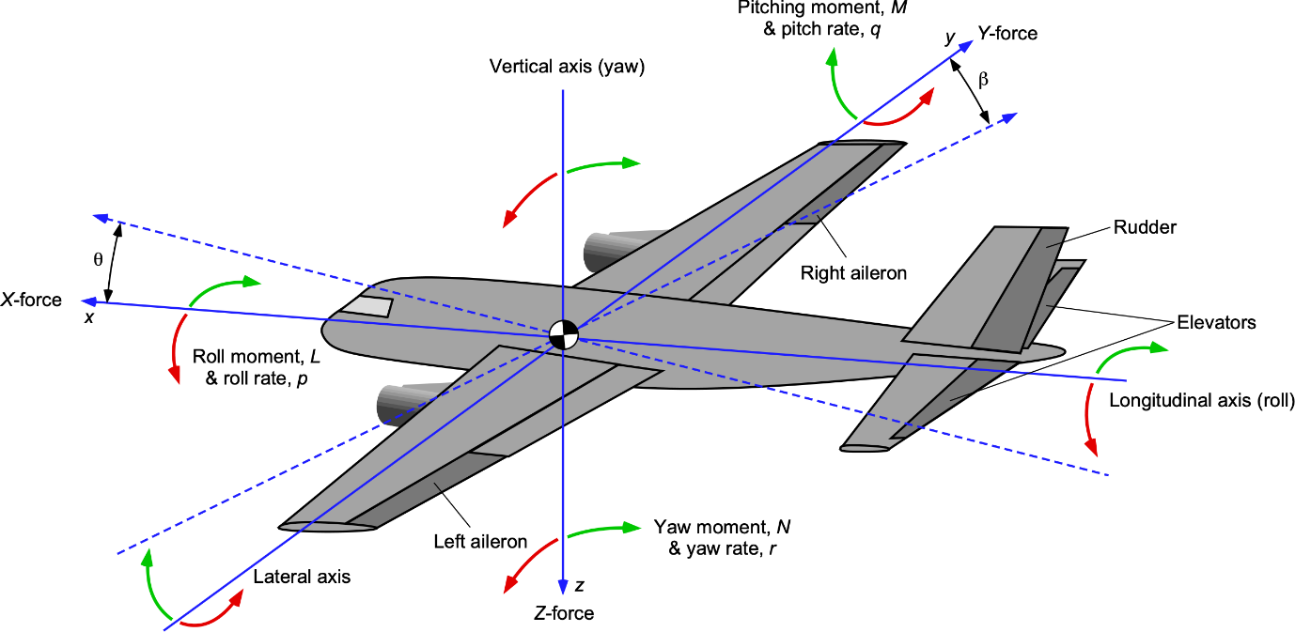

Aircraft–Engine Integration

Aircraft-engine integration for hypersonic vehicles (speeds above Mach 5) is an intensely coupled design challenge where the vehicle's forebody acts as the engine intake (compressing air via shock waves) and the aft fuselage acts as the exhaust nozzle.

Aerodynamic and Structural Coupling-
Forebody Compression: The nose and underside of the aircraft pre-compress incoming supersonic air before it enters the engine inlet, reducing the need for heavy internal mechanical compressor stages.
Aft Exhaust Integration: Single Expansion Ramp Nozzles (SERNs) use the aircraft’s own tail fuselage as an expansion surface, cutting down dead-weight drag but complicating pitch trim and thrust vectoring.
Shock Wave Interferences: Extreme external shock waves interact directly with the airframe boundary layer, heavily dictating stability, lift-to-drag ratios, and structural loads.

Thermal Management-
Aerodynamic Heating: Friction at Mach 5+ generates skin temperatures surpassing 1,000°C to 2,000°C, risking structural failure.
Fuel Cooling: Cryogenic fuels (like liquid hydrogen) or endothermic hydrocarbon fuels are circulated through internal airframe and engine walls to act as heat sinks before combustion.

Propulsion Cycle Challenges-
The Starting Problem: Air-breathing engines like scramjets cannot function from a standstill and require external boosters or combined-cycle turbine integration to reach operational supersonic speeds.

Mathematical Analysis

Objective
The purpose of this analysis is to investigate how the velocity corresponding to Mach 5 changes with altitude. Mach number is related to the local speed of sound, and the speed of sound depends on atmospheric temperature. Therefore, the same Mach number does not necessarily correspond to exactly the same velocity at every altitude. NASA explains that the speed of sound depends on the temperature and state of the gas, and that atmospheric conditions change with altitude.

Mathematical Relationship
The relationship between velocity, Mach number, and the local speed of sound can be written as:

$$V=Ma$$

where:
- V = velocity of the aircraft
- M = Mach number
- a = local speed of sound
For this investigation, the Mach number is fixed at:
$$M=5$$
Therefore:
$$V=5a$$

This means that once the local speed of sound is known, the corresponding Mach 5 velocity can be calculated.

Why Altitude Matters
The atmosphere changes with altitude. In the lower atmosphere, temperature generally decreases as altitude increases, and this affects the speed of sound.

For a simplified gas model, the speed of sound can be represented by:
$$a=\sqrt{γRT}$$

where:
- a = speed of sound
- γ = specific-heat ratio
- R = gas constant
- T = absolute temperature

Because temperature changes with altitude, the speed of sound also changes. Consequently, the velocity corresponding to Mach 5 can change with altitude.

Analysis
For each selected altitude, the local atmospheric temperature and corresponding speed of sound can be obtained from a standard-atmosphere model. The Mach 5 velocity can then be calculated using:
$$V=5a$$
The results can be organized into a table and represented using a graph of altitude versus Mach 5 velocity.
The analysis demonstrates that Mach number is not simply a fixed value in kilometres per hour. Instead, it represents a ratio between an aircraft's velocity and the local speed of sound.

Limitations
This analysis uses a simplified model of atmospheric conditions. In real hypersonic flight, the air can reach extremely high temperatures and may no longer behave like a simple ideal gas.
Therefore, the calculations in this section should be considered a simplified investigation rather than a complete simulation of a real hypersonic aircraft.

Conclusion of the Analysis
The analysis shows that altitude is an important factor in hypersonic flight because atmospheric temperature affects the local speed of sound. Since Mach number is defined relative to the local speed of sound, the actual velocity corresponding to Mach 5 can vary with atmospheric conditions.

Altitude (km) Mach 5 Velocity (m/s)
0 1702
5 1603
10 1498
15 1475
20 1475

The graph shows that the velocity corresponding to Mach 5 changes with altitude because the local speed of sound changes with atmospheric conditions. The calculated velocity decreases from sea level to higher altitudes in the selected range.

Major Engineering Challenges

Hypersonic aircraft travel at Mach 5 or higher (five times the speed of sound or more). At these extreme velocities, air friction and compression create temperatures exceeding 3,000°F (1,650°C), causing air molecules to break down into plasma. This creates massive barriers in thermal management, ultra-fast propulsion, and structural control.

Thermal Management and Materials-
Extreme Heat: Surface temperatures can melt standard aerospace metals like aluminium and titanium.
Material Breakdown: Air molecules dissociate into reactive oxygen and nitrogen radicals at temperatures over 3,000°C, causing heavy surface oxidation and structural ablation.
Solutions: Engineers use carbon composites, ultra-high temperature ceramics (UHTCs), and active regenerative cooling systems where fuel absorbs heat before combustion.

Propulsion Systems-
Engine Limits: Traditional turbojets and turbofans fail at high speeds because they cannot function efficiently once incoming air becomes supersonic.
Millisecond Combustion: Scramjets (supersonic combustion ramjets) use the vehicle's forward motion to compress air, but fuel must ignite and burn within milliseconds as air rushes through the engine.
Boost Requirements: Scramjets cannot work from a dead stop; they require rockets or conventional jets to reach initial supersonic speeds.

Aerodynamics and Control-
Shock Waves: Intense, violent shock waves form around the airframe, altering handling and changing lift-to-drag ratios unpredictably.
Fluid-Structure Interaction: High heat reduces structural stiffness, making the airframe prone to warping and severe aero-thermo-elastic distortion.
Autonomous Navigation: Human reaction times are far too slow at these speeds, requiring automated, AI-driven flight control systems to make split-second adjustments.

Communication and Testing-
Plasma Blackout: The ionized plasma sheath surrounding the craft blocks radio frequency signals, cutting off standard communication and telemetry.
Testing Limits: Ground wind tunnels cannot perfectly mimic the combined real-world duration, chemical reactions, and thermal stress of true hypersonic flight.

Future of Hypersonic Aircraft

Hypersonic aircraft operate at speeds exceeding Mach 5 (five times the speed of sound). Driven by innovations in scramjet propulsion and hydrogen power, startups like Hermeus and Hypersonix Launch Systems are developing ultra-fast vehicles aiming to shrink intercontinental travel to a matter of hours.

Core Technological Hurdles-
Extreme Heat Management: Friction at Mach 5+ generates thermal environments causing metal structures to warp or melt, requiring advanced carbon-composite materials and active regenerative cooling.
Propulsion Limitations: Standard jet turbines fail at supersonic intake velocities, forcing reliance on rocket boosters or air-breathing scramjets that demand precise supersonic ignition.
Communications Blackout: Extreme ionization creates a dense plasma sheath around the airframe, temporarily severing radio and telemetry links.

Primary Application Sectors-
Defence and Reconnaissance: Uncrewed high-speed surveillance craft—such as conceptual successors to the Blackbird—and rapid-strike missiles dominate near-term military funding.
Commercial Aviation: Long-haul passenger concepts strive for point-to-point global transit (e.g., London to New York in under two hours), though economic feasibility remains distant.
Affordable Space Access: Reusable hypersonic spaceplanes serve as high-altitude launch platforms to lower satellite and orbital payload deployment costs.

Discussion

The research indicates that hypersonic flight is not simply a problem of making an aircraft move faster. Aerodynamics, propulsion, heat management, materials, stability, and control must all work together.

Conclusion

Hypersonic aircraft operate in an extremely demanding flight regime. Achieving speeds above Mach 5 requires engineers to solve interconnected problems involving aerodynamics, propulsion, heat transfer, materials, and control.
Further research and technological development are needed to make hypersonic flight more practical and reliable.

References

Core hypersonics
- NASA. (n.d.). Hypersonics. NASA. NASA Hypersonics
- NASA Glenn Research Centre. (2021). Hypersonic aerodynamics. NASA. NASA Hypersonic Aerodynamics
- NASA Glenn Research Centre. (2021). Hypersonic aircraft. NASA. NASA Hypersonic Aircraft
Mach number and speed of sound
- NASA Glenn Research Centre. (2021). Role of the Mach number. NASA. Role of the Mach Number
- NASA Glenn Research Centre. (2021). Mach number. NASA. NASA Mach Number Guide
- NASA Glenn Research Centre. (2021). Speed of sound. NASA. NASA Speed of Sound
Scramjets and propulsion
- NASA. (2025). X-43A Hyper-X. NASA. NASA X-43A Hyper-X
- NASA. (2013). NASA's X-43A scramjet breaks speed record. NASA. NASA X-43A Speed Record
- NASA. (2013). NASA X-43A “Scramjet” being readied for Mach 10 flight. NASA. NASA X-43A Mach 10
- NASA. (2016). X-43A (Hyper-X). NASA. NASA X-43A Image Article
Advanced source
- NASA. (2016). Hypersonic air-breathing propulsion systems: Key physics and the categorization of modelling & simulation approaches. NASA. NASA technical paper

